**Weather Data Analysis – in Apache Spark**

I tried to bring analysis on the Data collected on the Weather Details of various countries. These data’s are of utmost importance and help us to analyse and understand the global impact across various countries.

The sources from which the Data are downloaded are :

<https://data.world/>

The raw files stored in the HDFS filesystem are :

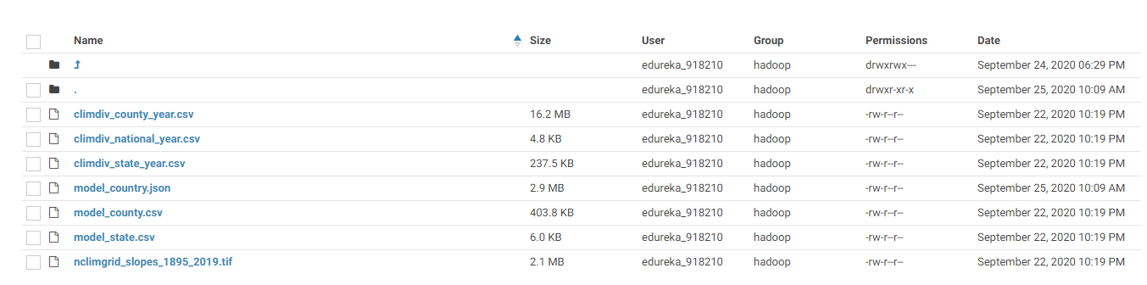

The commands that is used to transfer the files from the local system to the HDFS are :

hadoop fs -ls /user/edureka_918210/WeatherData

hadoop fs -put <filename1> <filename2> <filename3> <filename4> <filename5> <filename6> /user/edureka_918210/WeatherData

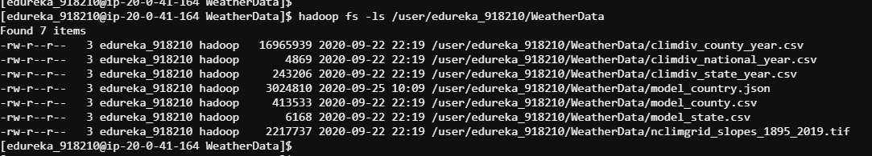

**The commands that are used in spark are as follows :**

var myDF_climdiv_county_year=spark.read.format("csv").option("delimiter",",").option("header","false").option("inferSchema","true").load("/user/edureka_918210/WeatherData/climdiv_county_year.csv").toDF("fips","year","temp","tempc")

var myDF_climdiv_national_year=spark.read.format("csv").option("delimiter",",").option("header","false").option("inferSchema","true").load("/user/edureka_918210/WeatherData/climdiv_national_year.csv").toDF("year","temp","tempc")

var myDF_climdiv_state_year=spark.read.format("csv").option("delimiter",",").option("header","false").option("inferSchema","true").load("/user/edureka_918210/WeatherData/climdiv_state_year.csv").toDF("fips","year","temp","tempc")

var myDF_model_country=spark.read.format("csv").option("delimiter",",").option("header","false").option("inferSchema","true").load("/user/edureka_918210/WeatherData/model_county.csv").toDF("fips","Fall","Spring","Summer","Winter","max_warming_season","Annual","CTYNAME","STNAME")

var myDF_model_country_json=spark.read.format("json").option("delimiter",",").option("header","false").option("inferSchema","true").load("/user/edureka_918210/WeatherData/model_country.json").toDF

var myDF_model_state=spark.read.format("csv").option("delimiter",",").option("header","false").option("inferSchema","true").load("/user/edureka_918210/WeatherData/model_state.csv").toDF("fips","Fall","Spring","Summer","Winter","max_warming_season","Annual","STUSAB","STATE_NAME","STATENS")

**Here's the schema details :**

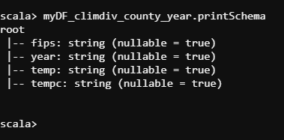

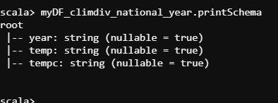

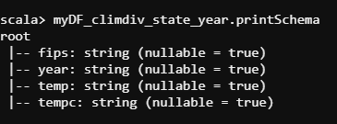

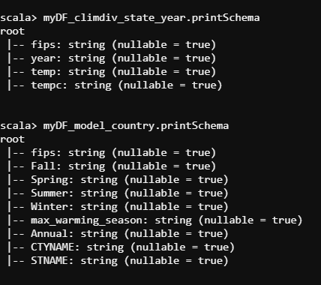

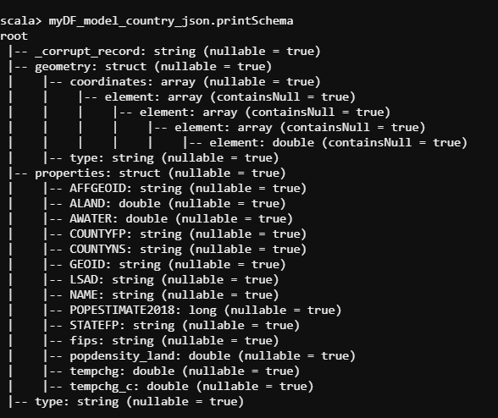

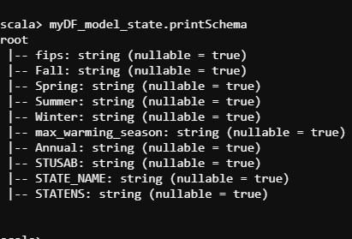

**The Result Details are shown below :**

myDF_climdiv_county_year.show(false)

myDF_climdiv_national_year.show(false)

myDF_climdiv_state_year.show(false)

myDF_model_country.show(false)

myDF_model_country_json.show(false)

myDF_model_state.show(false)

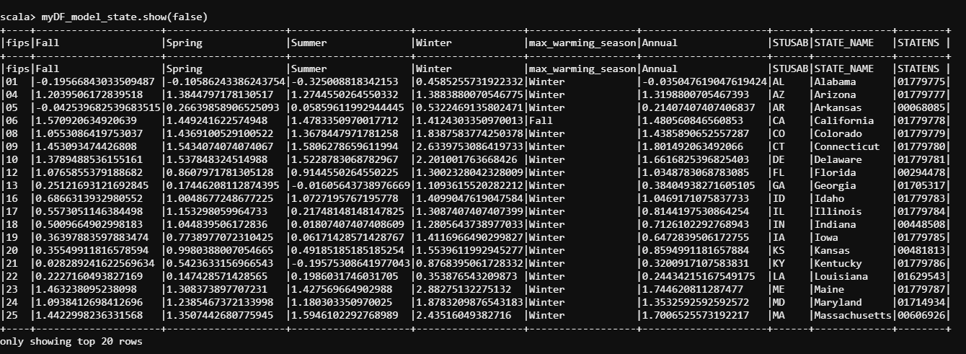

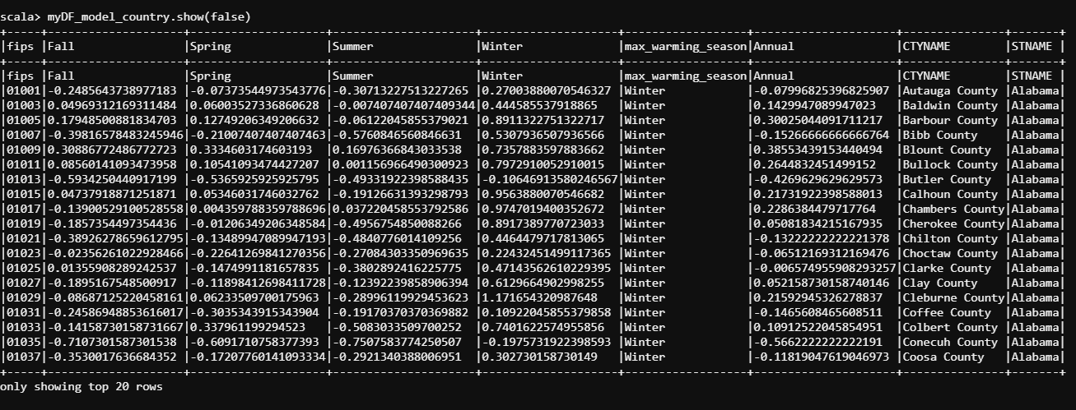

**SPARK SQL SUCCESSFUL CONVERSION**

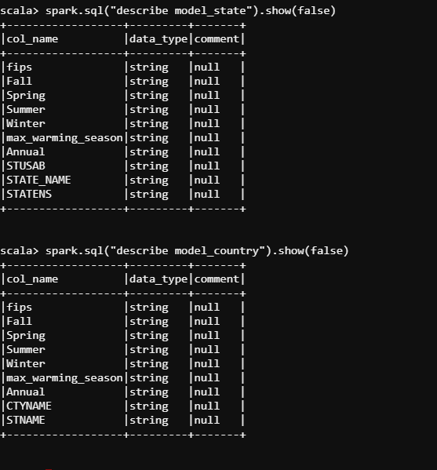

spark.sql("SELECT model_country.fips,model_country.FALL,model_country.Spring,model_country.Summer,model_country.Winter FROM model_country FULL OUTER JOIN model_state ON model_country.fips = model_state.fips").show(false)

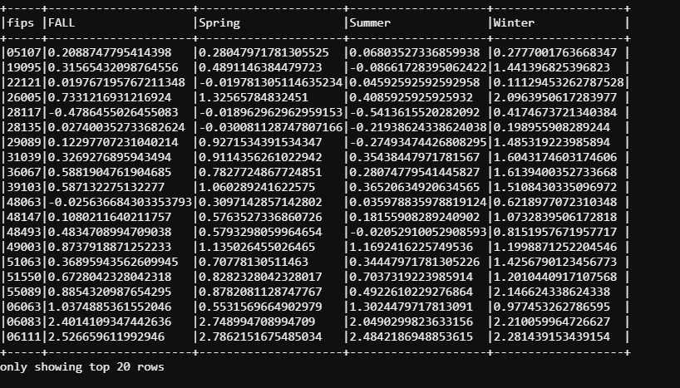

**SAVE AS CSV FILES**

spark.sql("SELECT model_country.FALL,model_country.Spring,model_country.Summer,model_country.Winter FROM model_country FULL OUTER JOIN model_state ON model_country.fips = model_state.fips").write.save("/user/edureka_918210/WeatherData/join_by_fips.csv")

